**CMSC203 Assignment 2 Implementation (Documentation)**

Class: CMSC203 CRN XXXX

 Program: Assignment #

Instructor:

 Summary of Description: (Give a brief description for each Program)

 Due Date: MM/DD/YYYY

 Integrity Pledge: I pledge that I have completed the programming assignment independently.

 I have not copied the code from a student or any source.

**Part1: Pseudo Code:** Here is a pseudo code for Assignment 2 program:

Google doc is most up to date:

https://docs.google.com/document/d/1zMUrJi9yzlLTJ2E5VBJ8WhdJZICLohNqW7OnaLJ4dGo/edit?usp=sharing

if not here are screenshots:

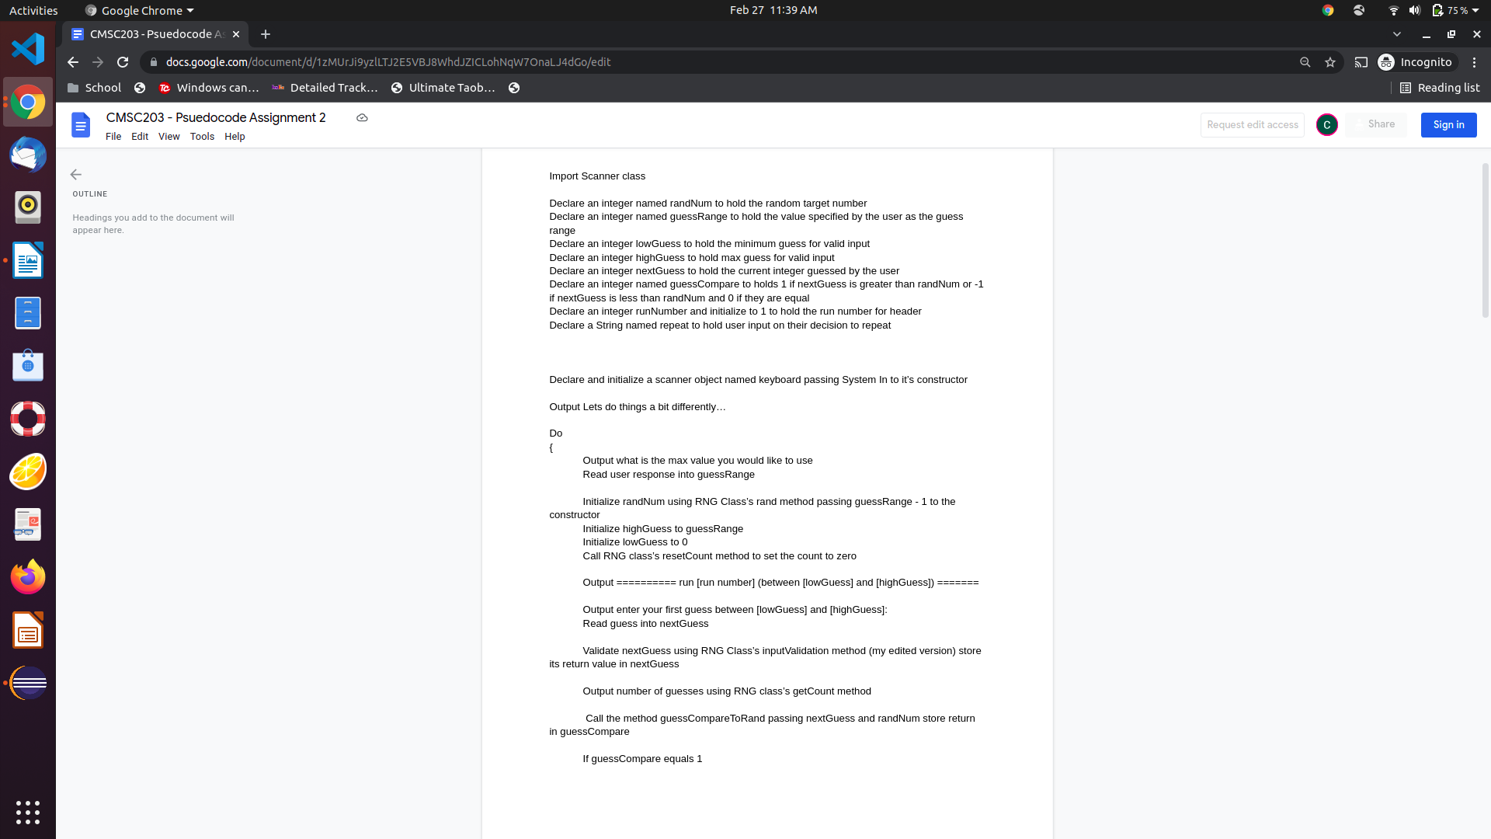

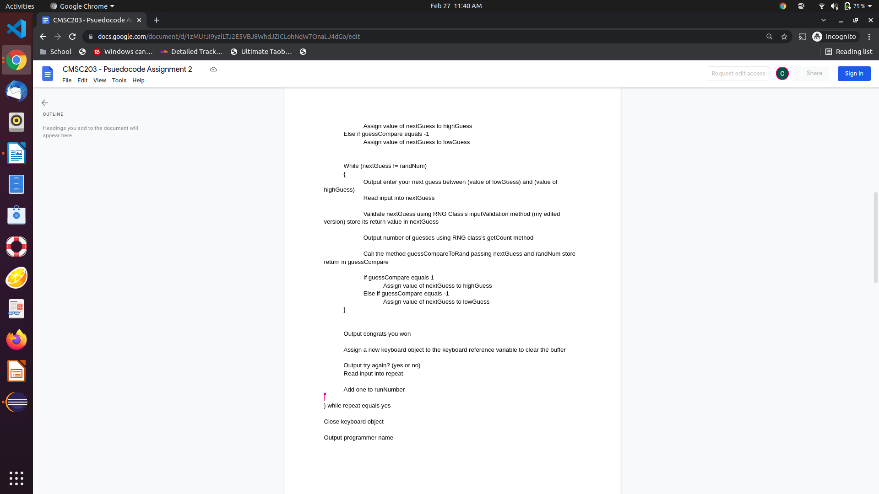

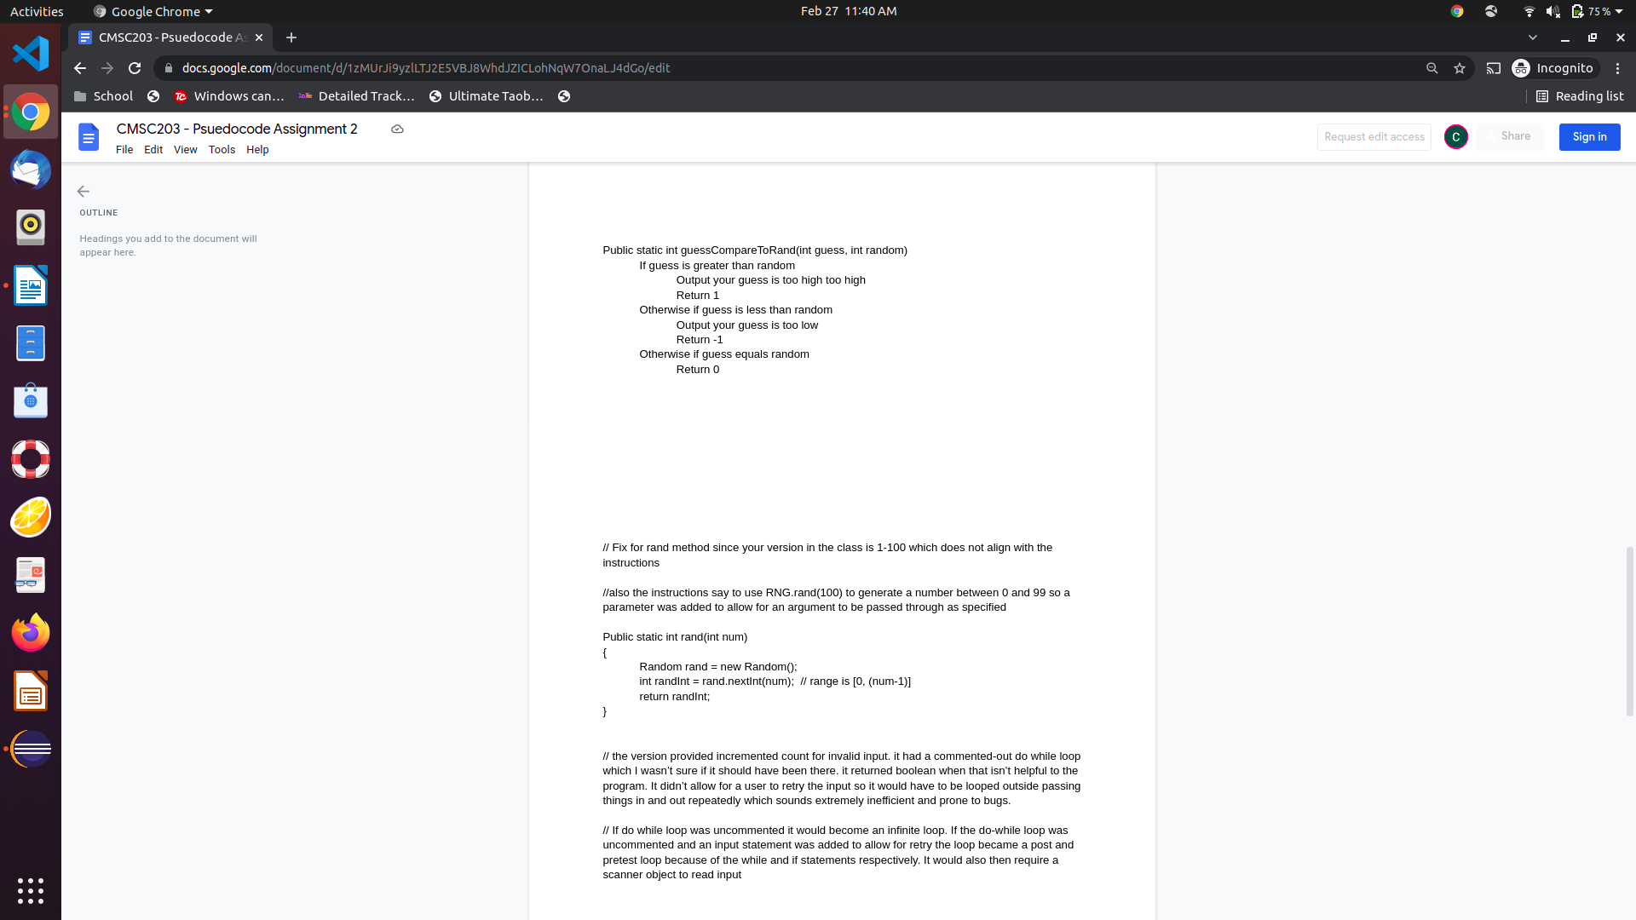

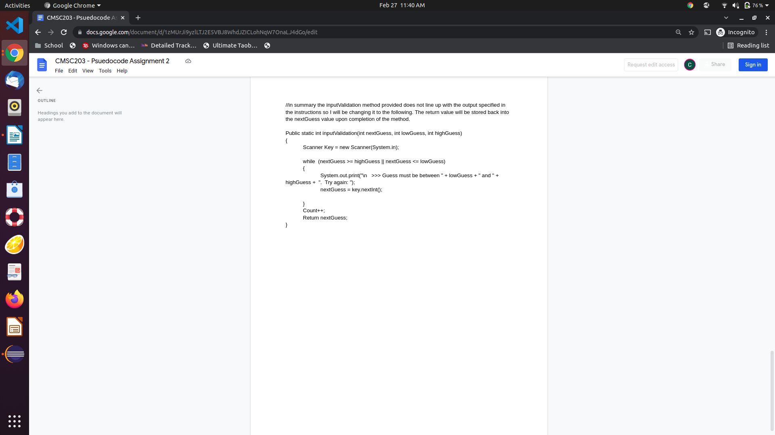

**Part2: Comprehensive Test Plan**

A good test plan should be comprehensive. This means you should have a few test cases that test when the input is in and out of range, division by 0, incorrect Data type, etc. (Provide valid and invalid input)

|  |  |  |  |  |
| --- | --- | --- | --- | --- |
| Cases | Input | Expected Output | Actual Output | Did Test Pass? |
| Case 1  (game from 0 to 100)  testing general game mechanics and invalid input logic | GuessRange = 100  guess 0  guess 100  guess -1  guess 101  guess 50  guess 50  win the game  no repeat | Starts game from 0 to 100  ERROR  ERROR  ERROR  ERROR  guess too high or low, adjust range accordingly, print number of (valid) guesses  error input BETWEEN (depends on high or low but can’t guess 50 again regardless because I already told you that’s not the value don’t be stupid)  congrats! You won  programmer name outputs | As expected. | yes |
| Case 2  testing variable game range mechanic vs randNum generator  also tests run number header | Guess range = 2  guess 1  repeat above a few times to make sure randNum is always inside the valid range of input | Start game from 0 to 2  you win | As expected | yes |
| Case 3  thought of one that should break it.  Input something invalid for guess range | Guess range = -100 | I expect it to break… | As expected.  Anything less than 0 would break Random class | It acted as expected but thats a bad thing  I’m going to implement input validation for range selector. I wont be updating it in the psuedocode though. |
| Case 4  testing guess range after adding input validation for it  (I updated minimum guessRange to be 4 so that no matter the range selection: 1 it works 2 you have to guess) | Guess range = 3  guess range = -1000  4  win game | ERROR guessRange too low  ERROR  start game between 0 and 4  mechanics work as expected | As expected. | yes |

**Part3: Screenshots related to the Test Plan:**

**Case 1**

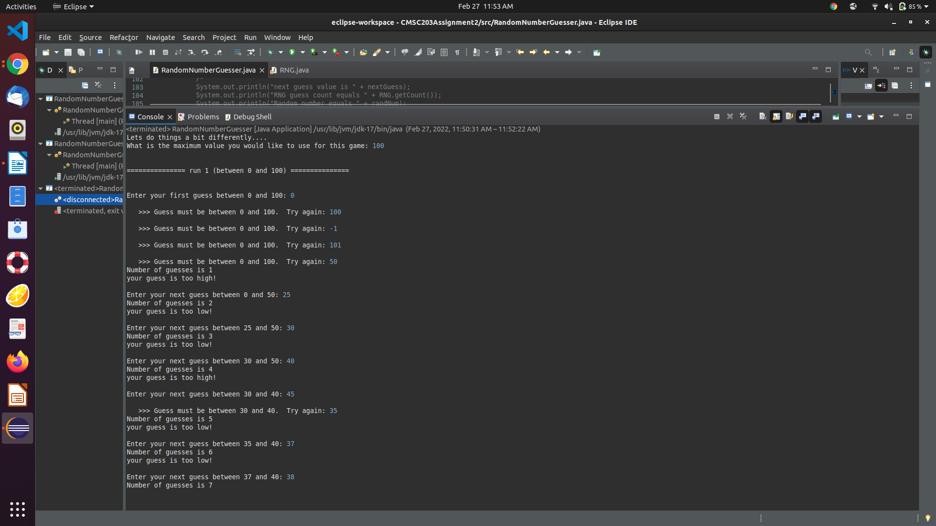

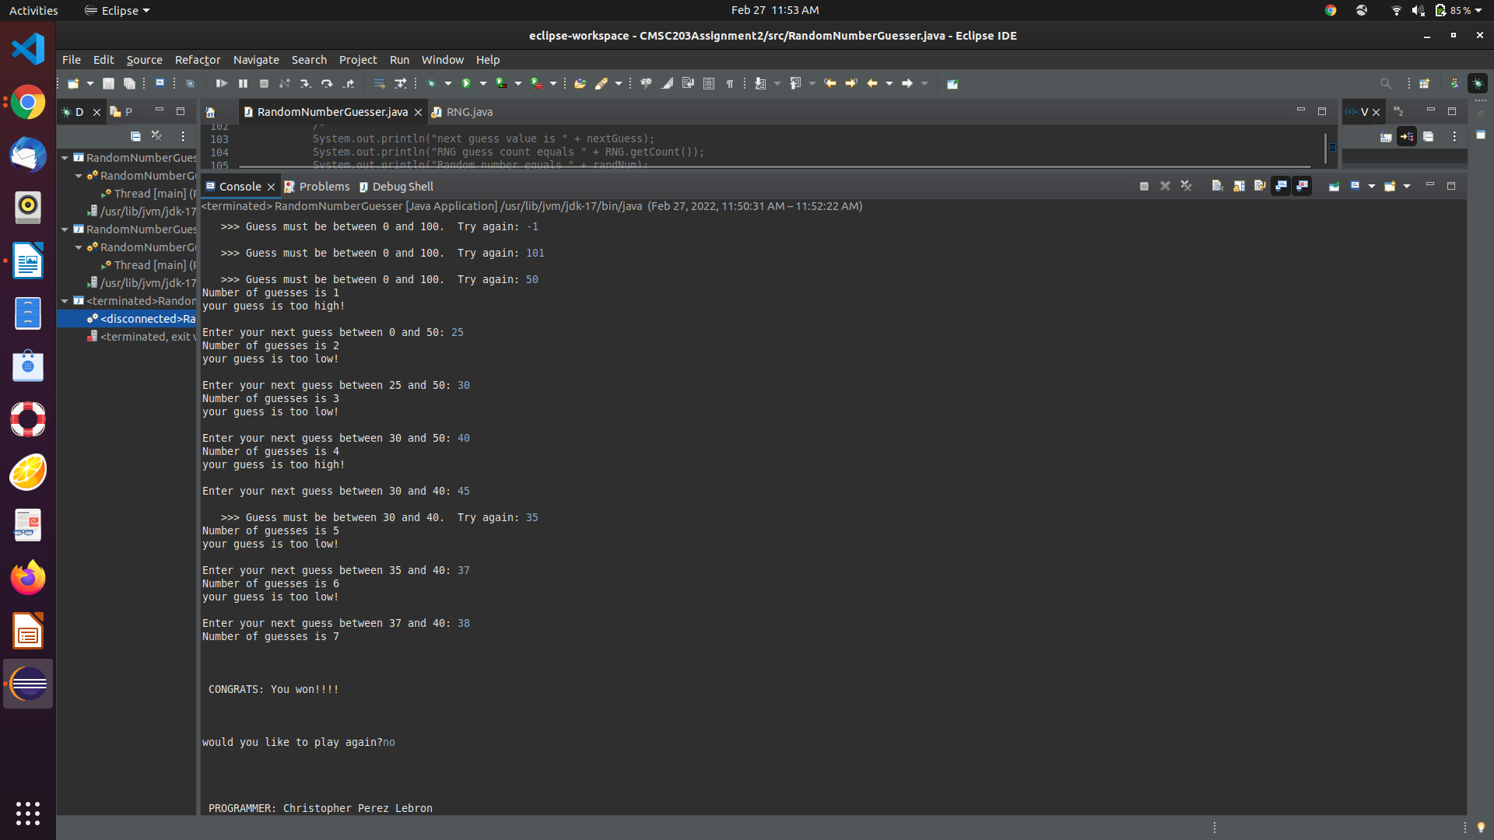

**Case 2**

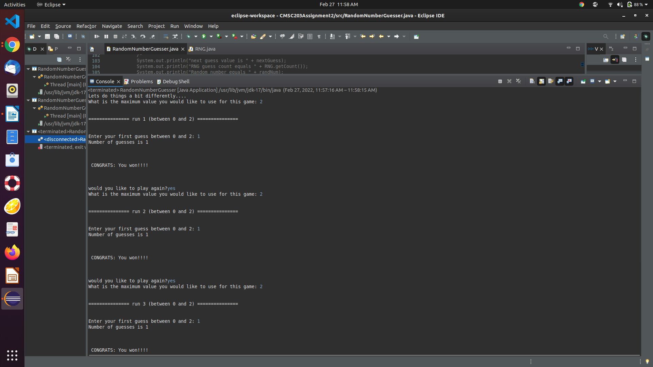

**Case 3**

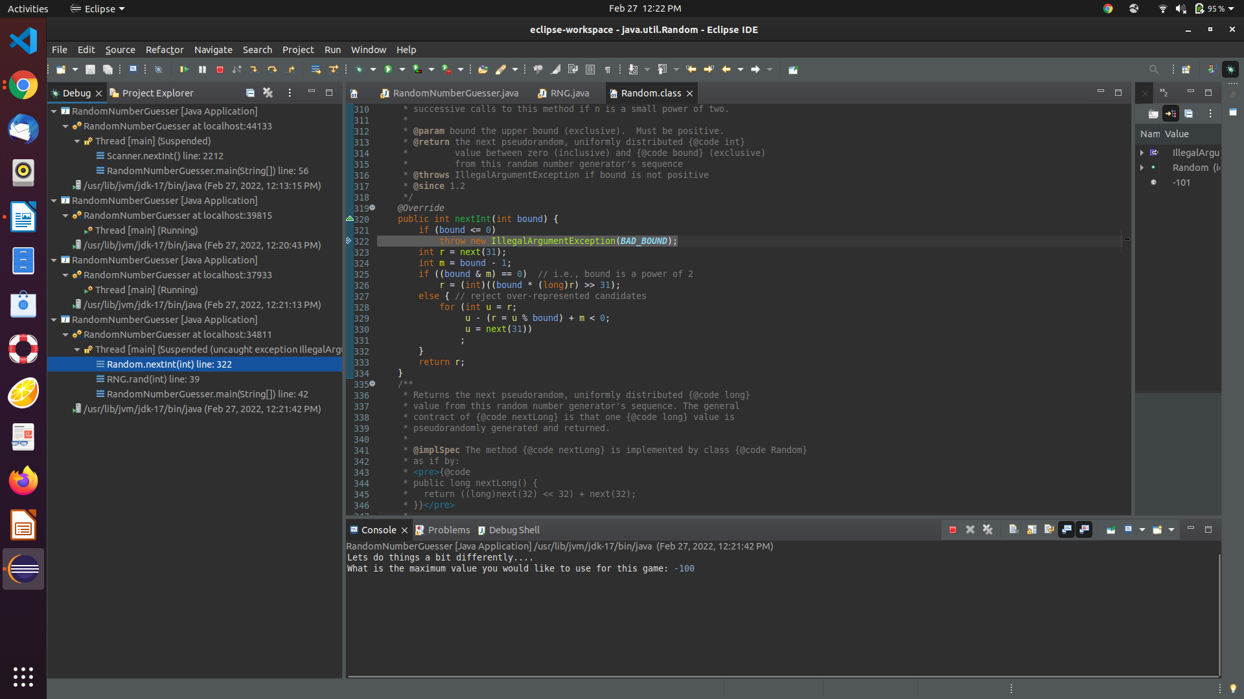

**Highlighted illegalArgumentException because a negative number was put into rand class’s nextInt method. Case 4 tests the fix**

**Case 4**

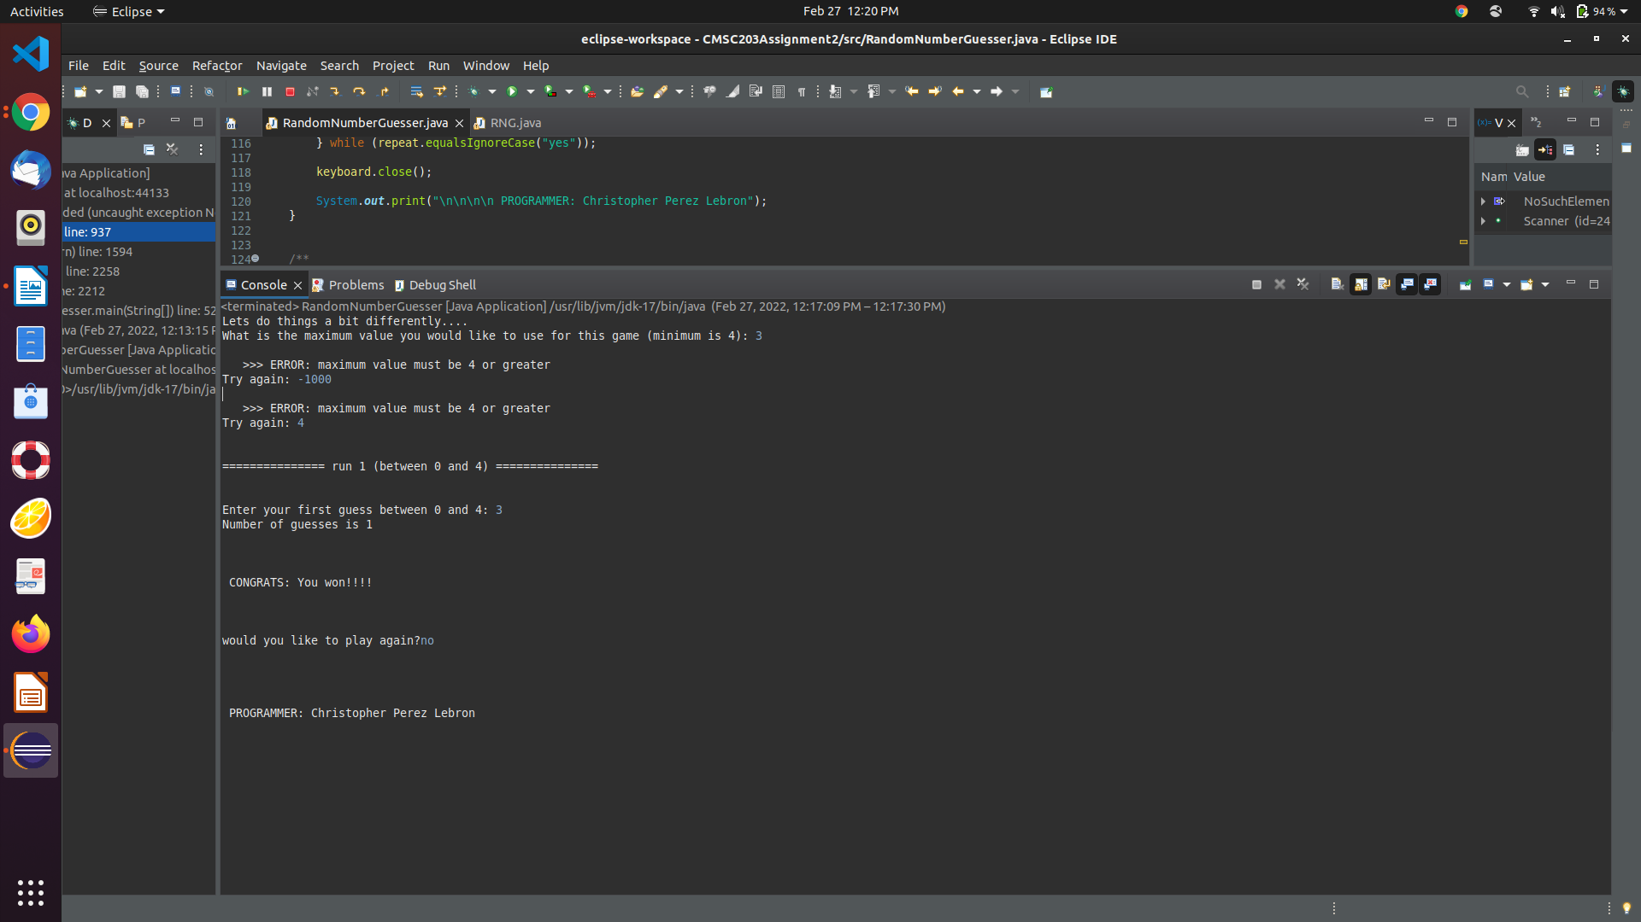

**GitHub Screenshot:**

**Lessons Learned** <Provide answers to the questions listed above>**:**

Write about your Learning Experience, highlighting your lessons learned and learning experience from working on this project.

What have you learned?

**When validating guessRange input I learned that putting a negative number into random class’s int method throws a illegalArgumentException.**

**I had to get creative with how to deal with a unknown number of newline characters so I had to explore options in depth.**

What did you struggle with?

**Nothing really**

What would you do differently on your next project?

**Nothing I’d enjoy revisiting it later in the semester and adding features to it.**

What parts of this assignment were you successful with, and what parts (if any) were you not successful with?

**Nothing was unsuccessful in my eyes.**

Provide any additional resources/links/videos you used to while working on this assignment/project.

Stack overflow whenever errors came up

**Check List:** <Provide answers to the column Y/N or N/A >**:**

|  |  |  |  |
| --- | --- | --- | --- |
| **#** |  | **Y/N** | **Comments** |
|  | **Assignment files:** |  |  |
|  | * FirstInitialLastName_ Assignment#_Moss.zip | **Yes or No** | **yes** |
|  | * FirstInitialLastName_Assignment#.docx/.pdf | **Yes or No** | **yes** |
|  | * Source java files | **Yes or No** | **yes** |
|  | **Program compiles** | **Yes or No** | **yes** |
|  | **Program runs with desired outputs related to a Test Plan** | **Yes or No** | **yes** |
|  | **Documentation file:** |  |  |
|  | * Comprehensive Test Plan | **Yes or No** | **yes** |
|  | * Screenshots related to the Test Plan | **Yes or No** | **yes** |
|  | * Screenshots of your GitHub account with submitted Assignment# (if required) | **Yes or No or N/A** |  |
|  | * UML Diagram (if required) | **Yes or No or N/A** | **n/a** |
|  | * Algorithms/Pseudocode (if required) | **Yes or No or N/A** | **yes** |
|  | * Flowchart (if required) | **Yes or No or N/A** | **n/a** |
|  | * Lessons Learned | **Yes or No** | **yes** |
|  | * Checklist is completed and included in the Documentation | **Yes or No** | yes |